13.61: a) Rewriting Eq. (13.22) in terms of the period and solving,
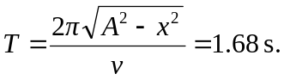
b) Using the result of part (a),
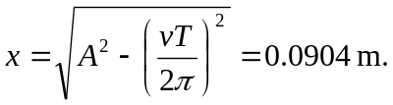
c) If the block is just on the verge of slipping, the friction force is its maximum, 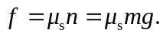 Setting this equal to

